**Solution:**

1. How are restaurant inspection grades in all of NYC distributed?

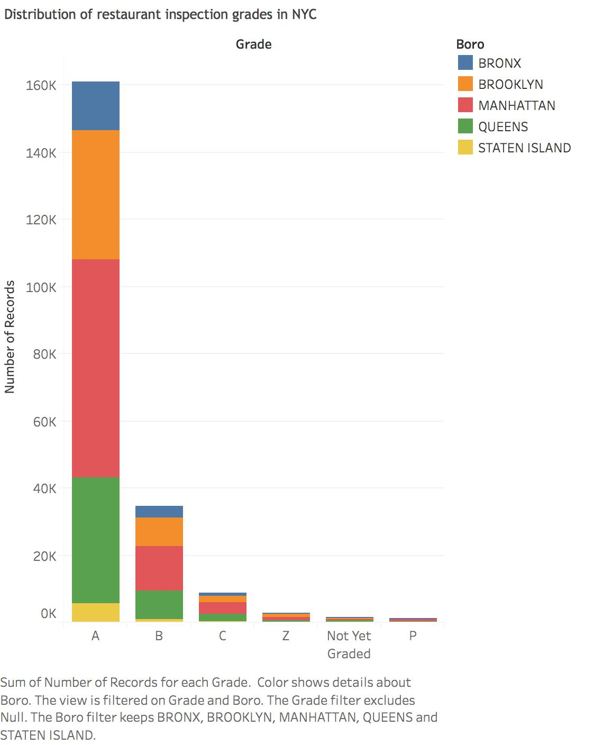

1. How do Manhattan restaurant grades compare to Brooklyn?

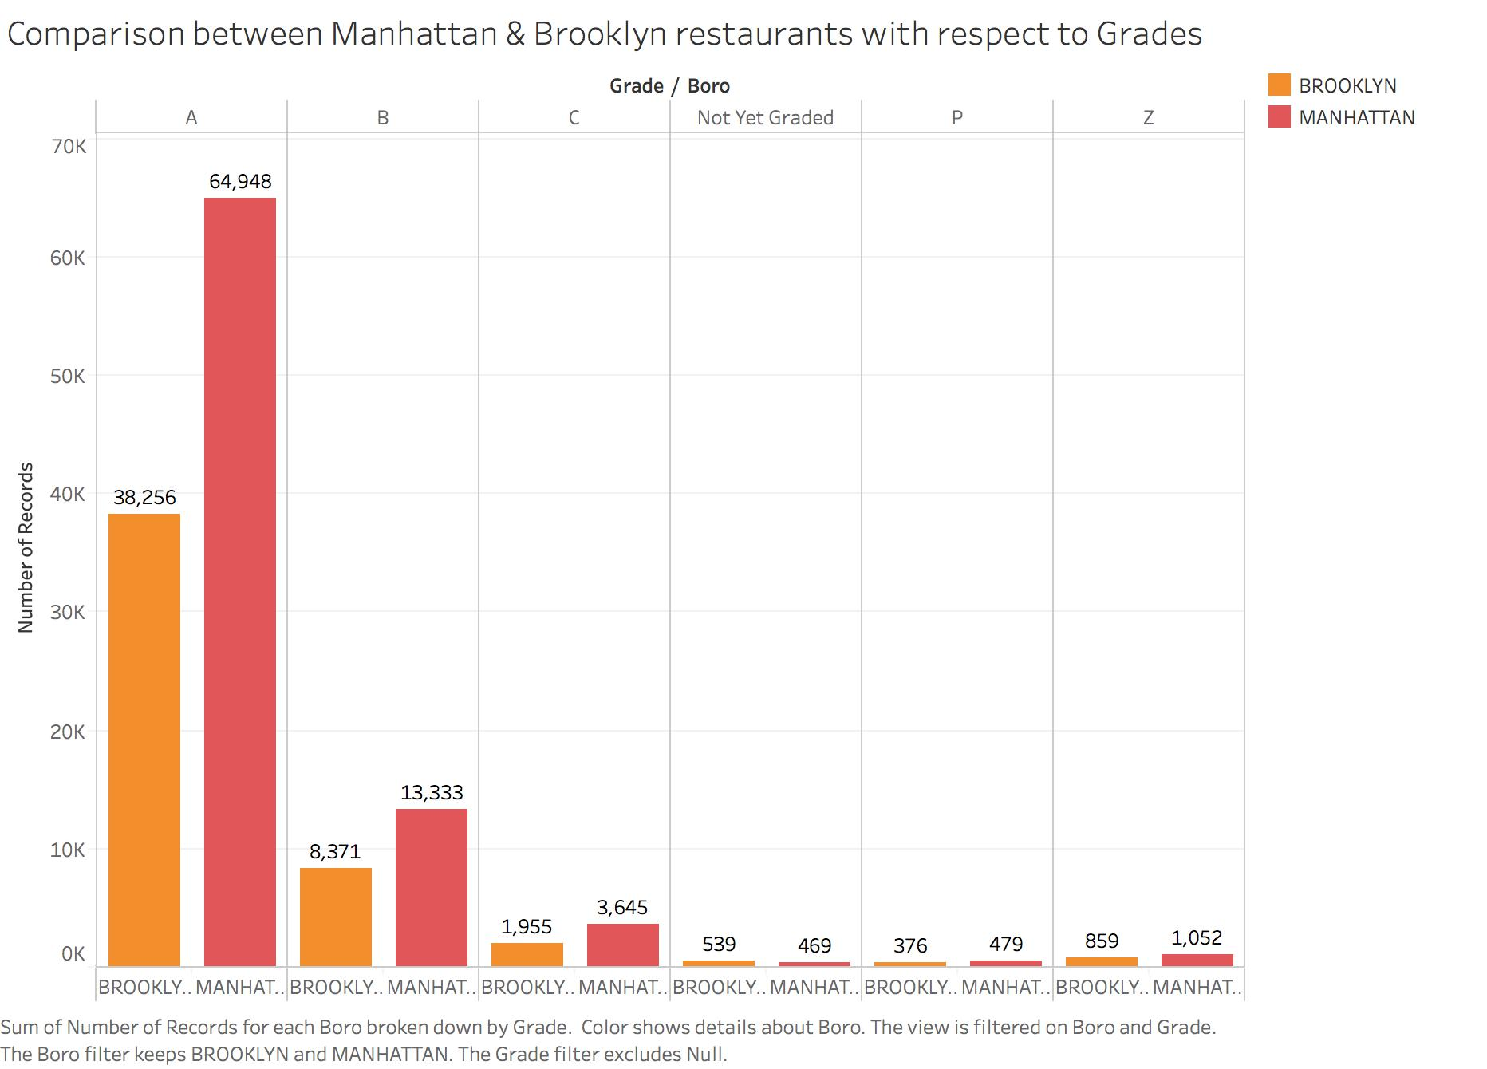

1. What is the most common type of cuisine for restaurants in Staten Island? How does this compare to Queens?

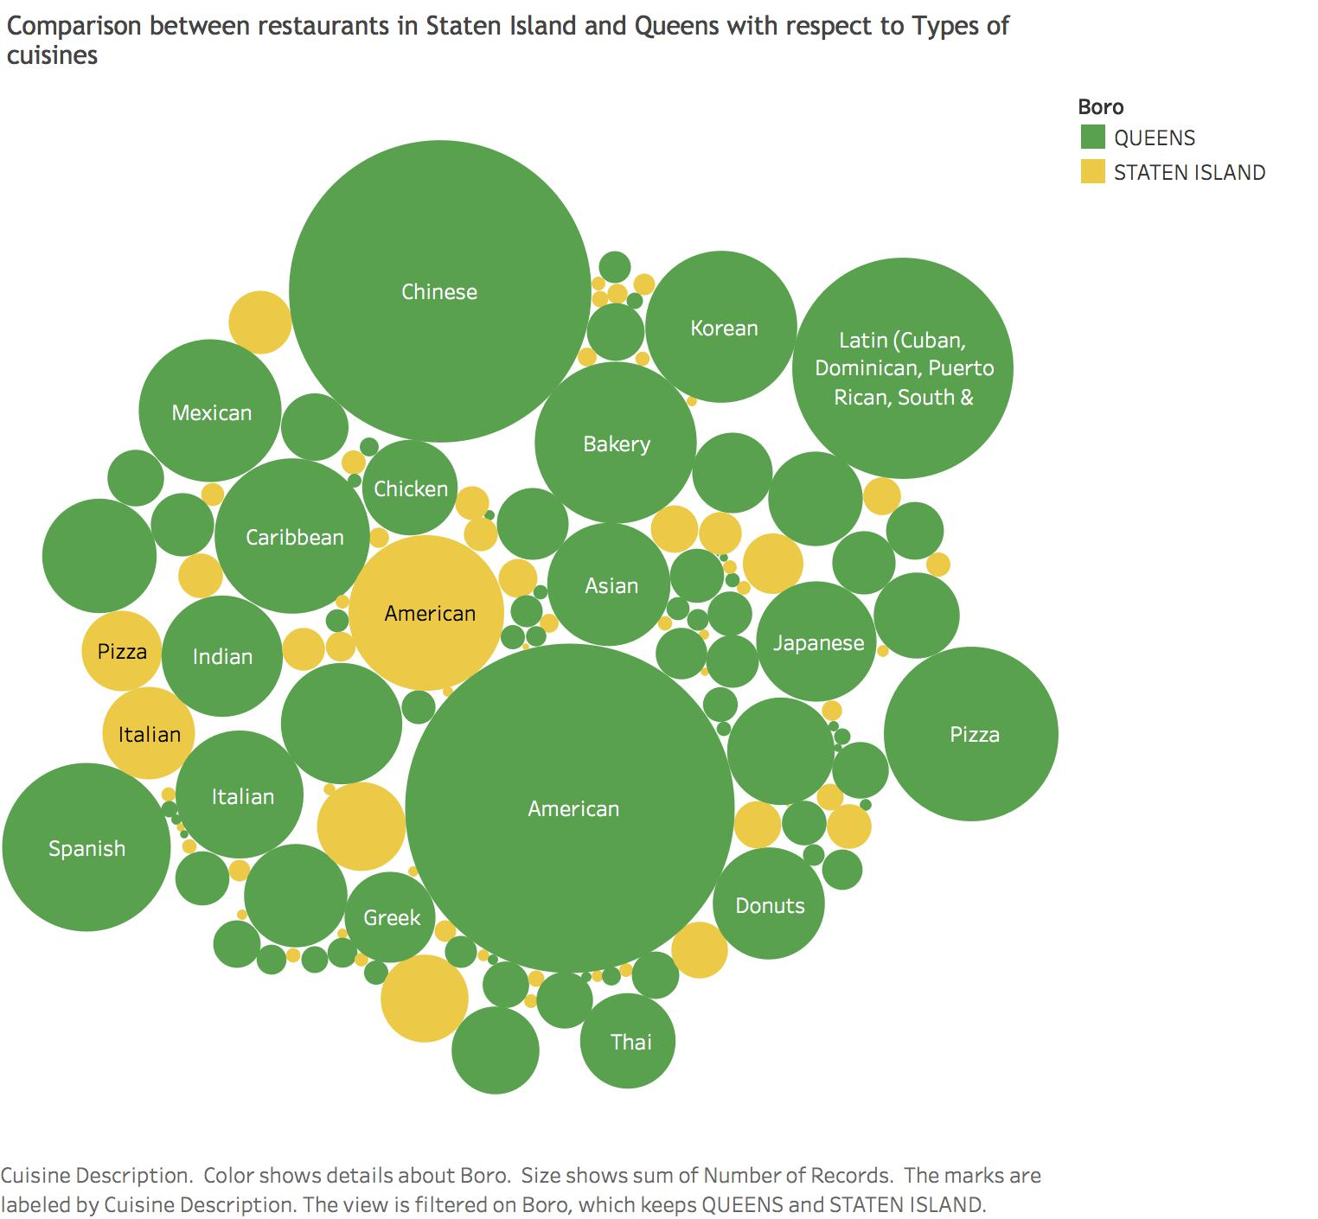

1. Are inspection grades for certain types of restaurants better than others?



**Filtering 20 out of 84 cuisine types**

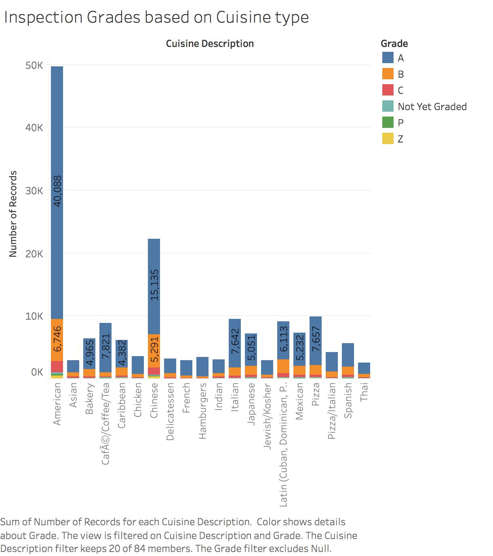

4.1 What type of restaurants has the worst ratings?

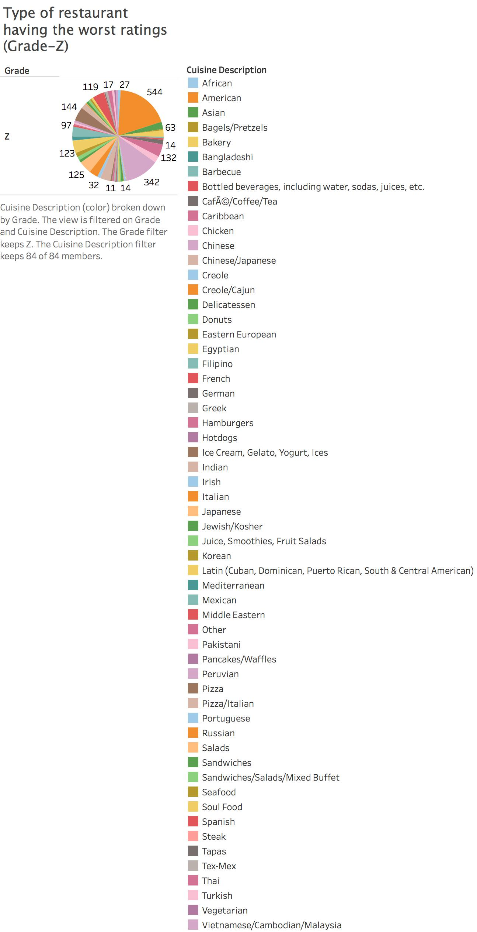

**Filtering 20 out of 84 cuisines**

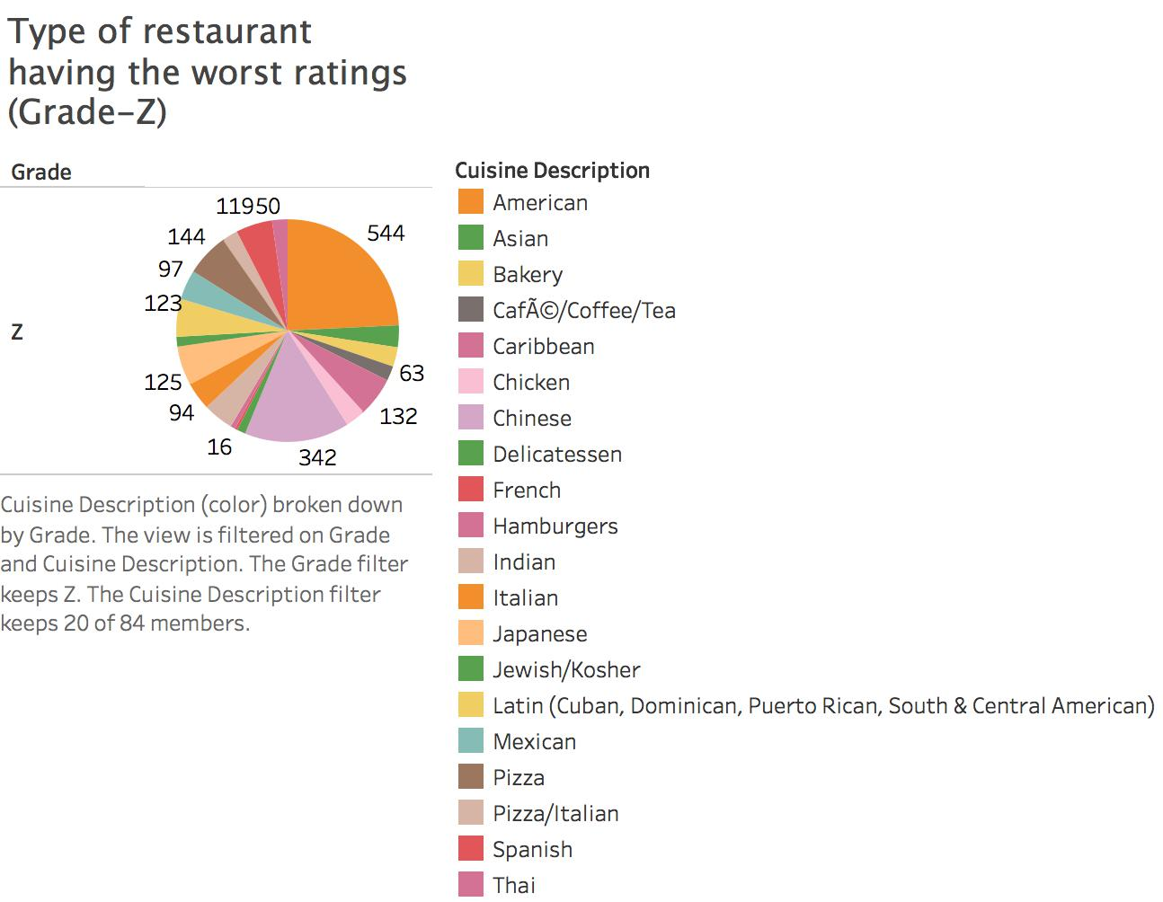

1. Is the quality/cleanness of restaurants improving or worsening over time?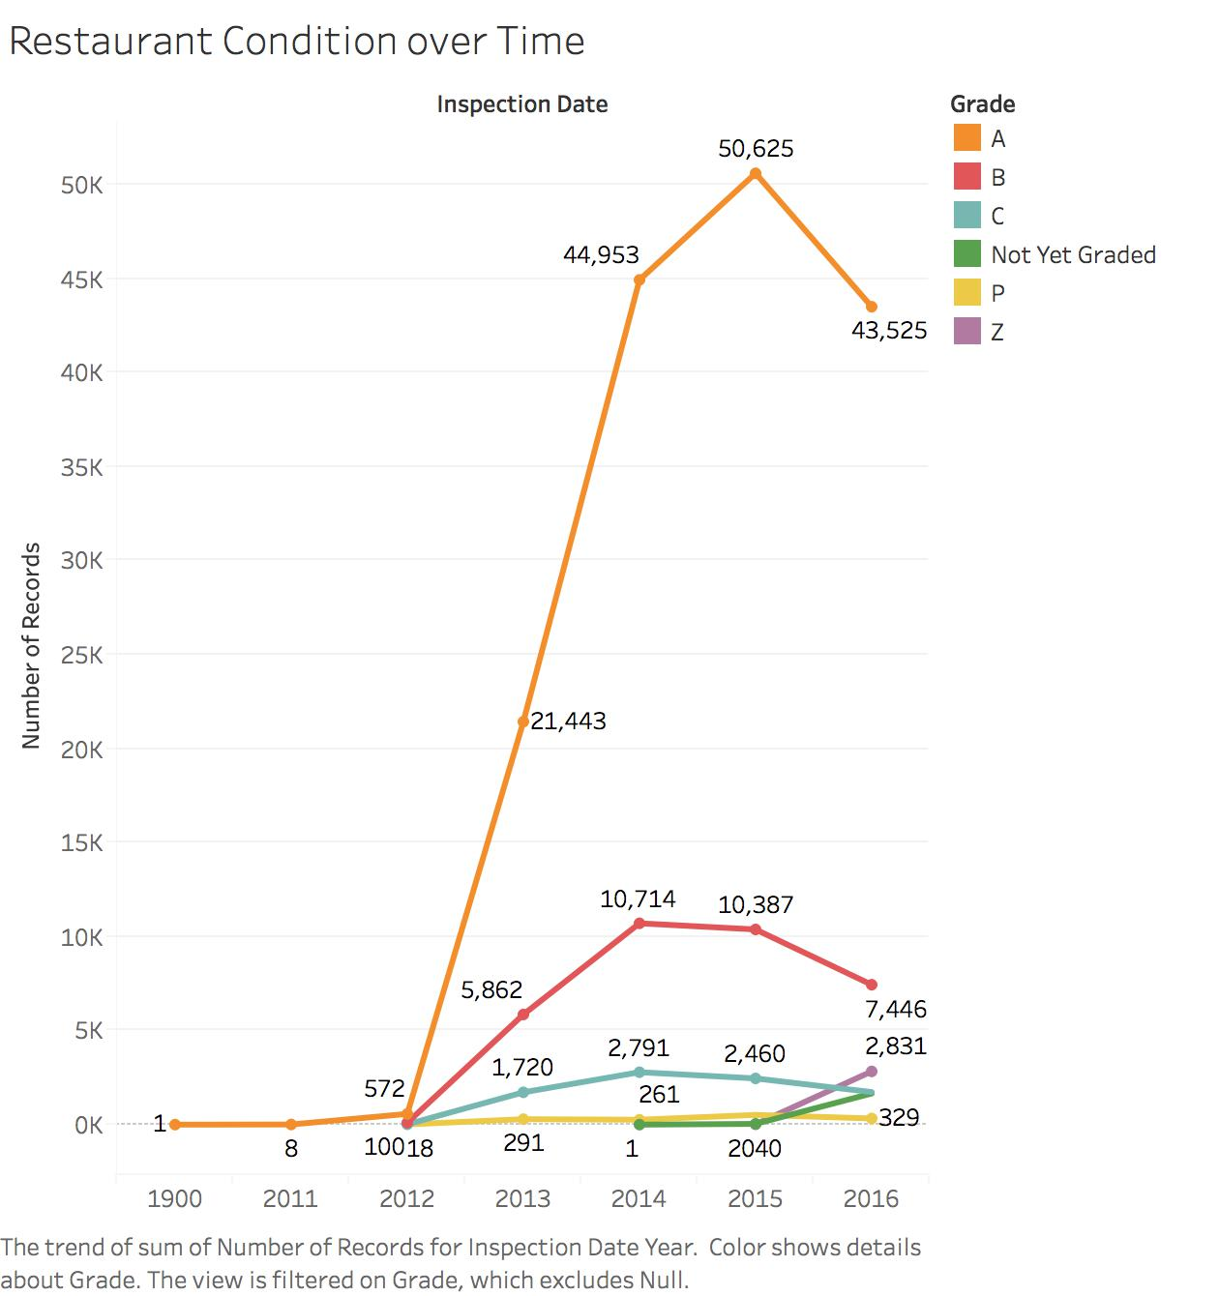
2. What are the top 3 causes for violations?



